INTRO TO SQL
Introduction to SQL
Agenda
- What is SQL?
  - Key Functions of SQL
- Types of Databases
  - Relational Databases
  - Non-Relational Databases
  - SQL vs. NoSQL Databases
What is SQL?
SQL (Structured Query Language) is a powerful language used to communicate with and manage data stored in relational databases. It enables users to create, modify, and manipulate data structures and records. SQL is commonly employed to query, insert, update, and delete records, as well as to design and alter the database itself. With its versatility, SQL can handle complex queries and process large volumes of data, making it the most widely used language for managing databases across various applications.
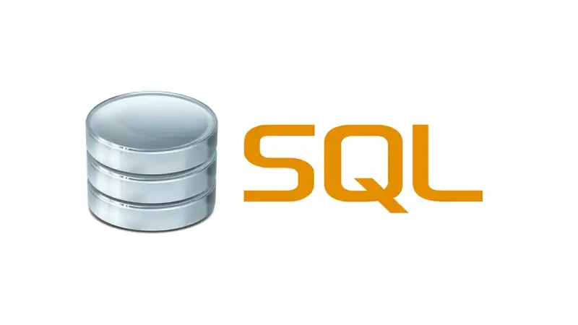
Example: Consider Ayush, who owns a retail business. To analyze customer spending habits in her store, Ayush can use SQL to query his database and generate a report listing customers who made purchases over the past year, the items they bought, and the cost of each item. This information allows Ayush to understand each customer's spending patterns, the quantity of items purchased, and identify the most popular products.
Key Functions of SQL:
- Data Querying: Retrieve data from a database using the SELECT statement.
- Data Manipulation: Perform operations like inserting (INSERT), updating (UPDATE), and deleting (DELETE) data.
- Data Definition: Define the structure of a database using Data Definition Language (DDL) commands like CREATE, ALTER, and DROP.
- Data Control: Control access and permissions to data using Data Control Language (DCL) commands like GRANT and REVOKE.
Importance of SQL
- Industry Standard: SQL is the most widely used database language across the globe. Almost every relational database uses SQL for database queries and management.
- Scalability: SQL databases can handle a huge volume of data, making it essential for data-driven businesses and organizations.
- Cross-Platform Compatibility: SQL can be used on various platforms (Windows, Mac, Linux) and supports different database systems.
- Declarative Nature: SQL is a declarative language, which means that users specify what they want to do with data rather than how to do it, simplifying database management.
- Data Integrity: SQL helps enforce data integrity and security with features like constraints (e.g., PRIMARY KEY, FOREIGN KEY) and permissions (DCL commands).
Applications of SQL
- Data Storage: SQL is the standard language used to store and manipulate data in relational databases.
- Data Definition: SQL is used to create, alter, and manage the structure of database objects such as tables, indexes, and views.
- Data Retrieval: SQL allows users to query and filter data from one or more tables, returning specific information.
- Data Manipulation: SQL can be used to update, insert, and delete records within a database.
- Data Security: SQL manages access controls, granting and revoking user permissions to maintain data security.
- Data Analysis: SQL supports data analysis by performing calculations, generating reports, and creating visualizations based on queried data.
Advantages of SQL
- Ease of Use: SQL is user-friendly, with clear syntax that makes it easy to learn and understand. Writing queries and reading results is straightforward for users of all levels.
- Standardization: SQL is a standardized language, making it compatible with numerous database management systems. This ensures seamless data transfer across different systems.
- Scalability: SQL can handle large datasets and scale with growing business needs.
- Flexibility: SQL is highly adaptable, capable of handling both simple queries and complex data analysis.
- Security: SQL includes built-in security features such as user authentication, encryption, and access control, protecting data from unauthorized access.
- Performance: SQL is optimized for performance, allowing for quick query execution and real-time data retrieval, making it a valuable tool for decision-making.
Limitations of SQL
- Complexity: SQL can be difficult to learn, especially for beginners unfamiliar with database design and programming concepts.
- Limited Support for Non-Relational Data: SQL is specifically designed for relational databases, which may not be ideal for managing non-relational data formats like JSON or XML.
- Cost: Some SQL-based database management systems are expensive to license, particularly for large-scale enterprise applications.
- Scalability Challenges: Although SQL is scalable, managing very large datasets with a centralized architecture can pose challenges and lead to performance bottlenecks.
- Performance Issues with Large Datasets: SQL may experience performance degradation when handling exceptionally large datasets or highly complex queries, potentially impacting user experience.
Types of Databases
Databases are categorized primarily into two types based on their structure and how they store data: Relational Databases and Non-Relational Databases.
Relational Databases (SQL)
- Relational databases store data in tables (rows and columns) and maintain relationships between different tables using keys (Primary Key, Foreign Key).
- SQL is used to query and manipulate relational databases.Popular Relational Databases:
  - MySQL
  - PostgreSQL
  - Microsoft SQL Server
  - Oracle Database
Non-Relational Databases (NoSQL)
- Non-relational databases (often referred to as NoSQL databases) do not follow a tabular structure. Instead, they store data in various formats such as key-value pairs, documents, graphs, or columns.
- NoSQL databases are more flexible and are often used when dealing with large volumes of unstructured or semi-structured data.Popular Non-Relational Databases:
  - MongoDB (Document-based)
  - Cassandra (Column-family based)
  - Redis (Key-value store)
  - Neo4j (Graph-based)
Relational vs. Non-Relational Databases
Relational Databases (SQL):
- Data is stored in structured tables with relationships between different tables.
- Provides ACID (Atomicity, Consistency, Isolation, Durability) properties, ensuring data reliability and integrity.
- Suitable for complex querying and data analysis.
- More rigid schema with predefined structure.
Non-Relational Databases (NoSQL):
- Data is stored in a flexible format (key-value pairs, documents, columns, etc.).
- Offers scalability and better performance for unstructured or semi-structured data.
- Provides BASE (Basically Available, Soft state, Eventual consistency) for high availability and distributed systems.
- Used for high-throughput, large datasets with simple queries.
SQL vs. NoSQL
- SQL (Relational Databases):
  - Uses Structured Query Language (SQL) for database interaction.
  - Suitable for applications where data relationships and integrity are crucial.
  - Requires a fixed schema, making it less flexible in terms of data structure.
- NoSQL (Non-Relational Databases):
  - No specific query language; interaction happens through APIs or other query models depending on the database (e.g., MongoDB uses MQL—Mongo Query Language).
  - Offers flexibility in schema design, allowing the data model to evolve over time.
  - Ideal for high-velocity, high-volume data with minimal structure, such as real-time data processing or big data applications.
Popular Database Management Systems (DBMS)
- MySQL:
  - Open-source relational database known for its speed and reliability. Widely used in web applications.
- PostgreSQL:
  - An advanced, open-source relational database with support for more complex operations such as JSON data types and advanced indexing.
- Microsoft SQL Server:
  - A commercial relational database developed by Microsoft, offering robust integration with Microsoft’s technology stack and enterprise-grade features.
- Oracle Database:
  - A powerful relational database known for handling large-scale enterprise systems. It offers advanced security and performance features.
- MongoDB:
  - A popular NoSQL database that stores data in JSON-like documents. Used in applications requiring fast, flexible, and scalable data storage.
How to Install MySQL Workbench?
Step 1: Open the MySQL website on a browser. Click on the following link:https://dev.mysql.com/downloads/windows/installer/8.0.html Step 2: Select the Downloads option.
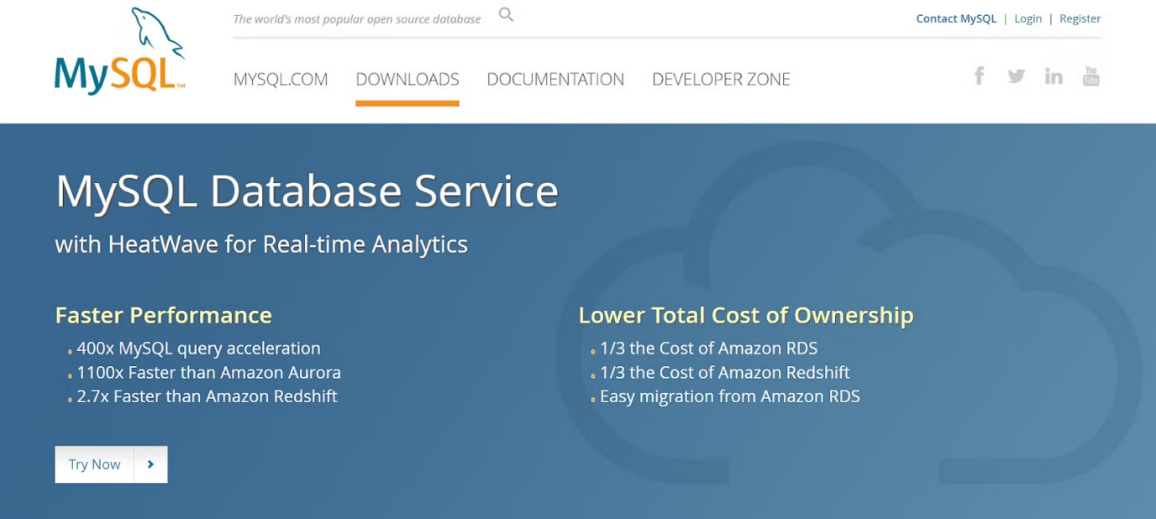
Step 3: Select MySQL Installer for Windows.
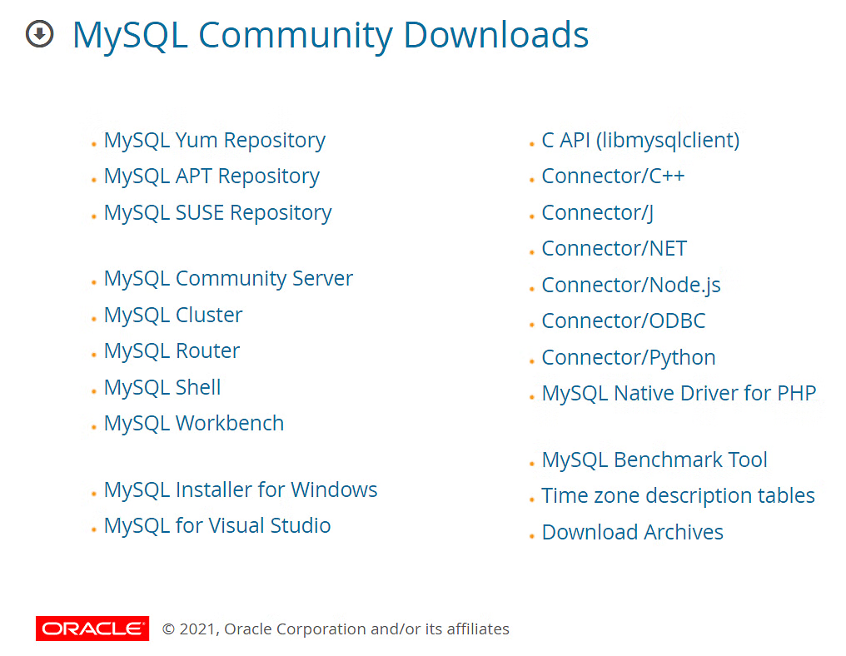
Step 4: Choose the desired installer and click on download.
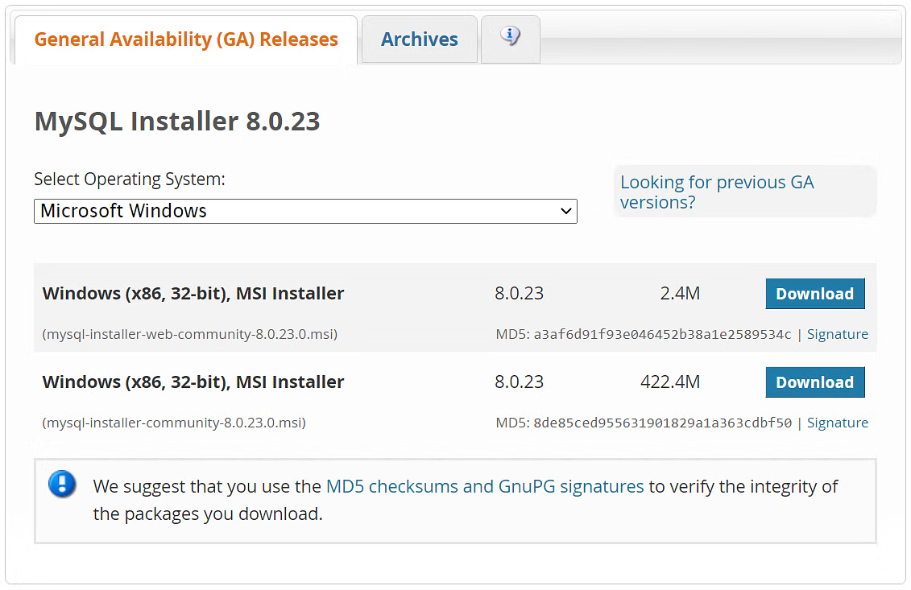
Step 5: After the download, open the installer.
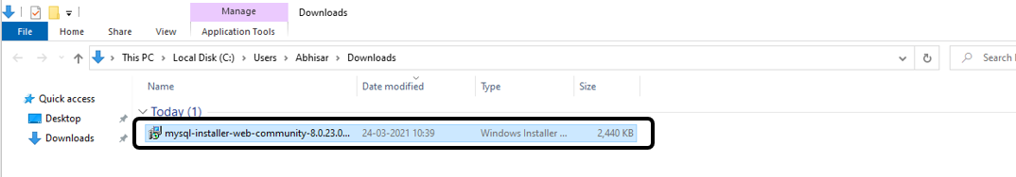
Step 6: It will ask for permission; when it does, click Yes. The installer will then open. Now, it will ask to choose the setup type. Here, select Custom.
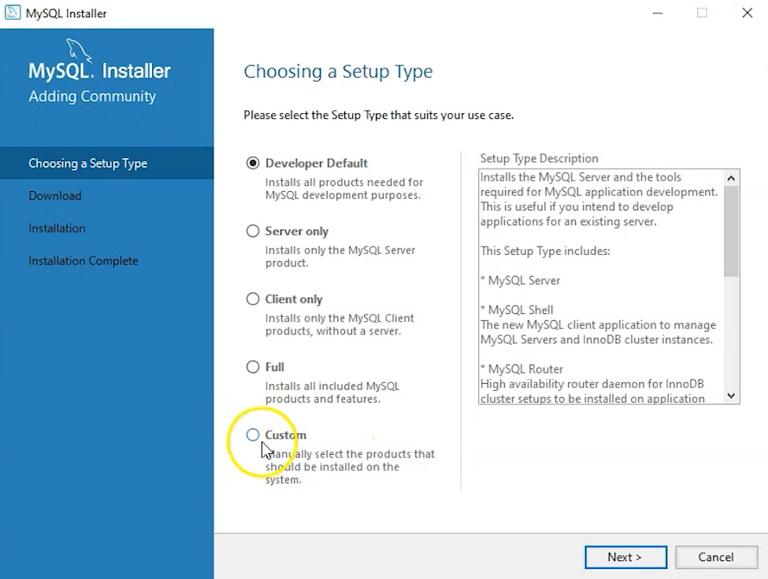
Step 7: Click on Next. With this, you will install MySQL server, MySQL Workbench, and MySQL shell.
Step 8: Open MySQL Servers, select the server you want to install and move it to the Products/Features to be installed window section. Now, expand Applications, choose MySQL Workbench and MySQL shell. Move both of them to ‘Products/Features to be installed’.
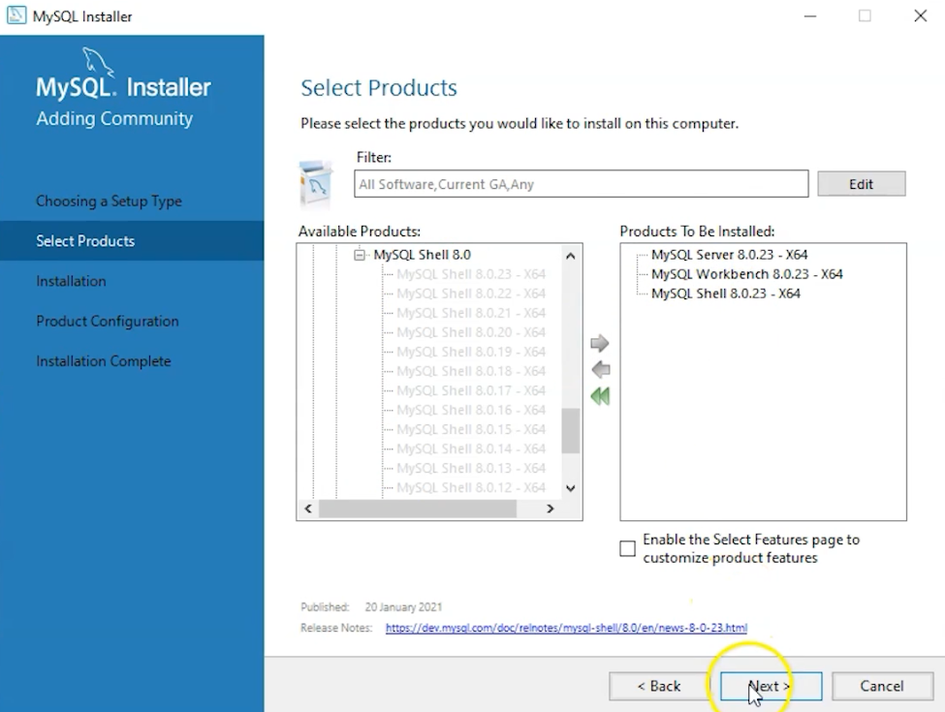
Step 9: Click on the Next button. Now, click on the Execute button to download and install the MySQL server, MySQL Workbench, and the MySQL shell.
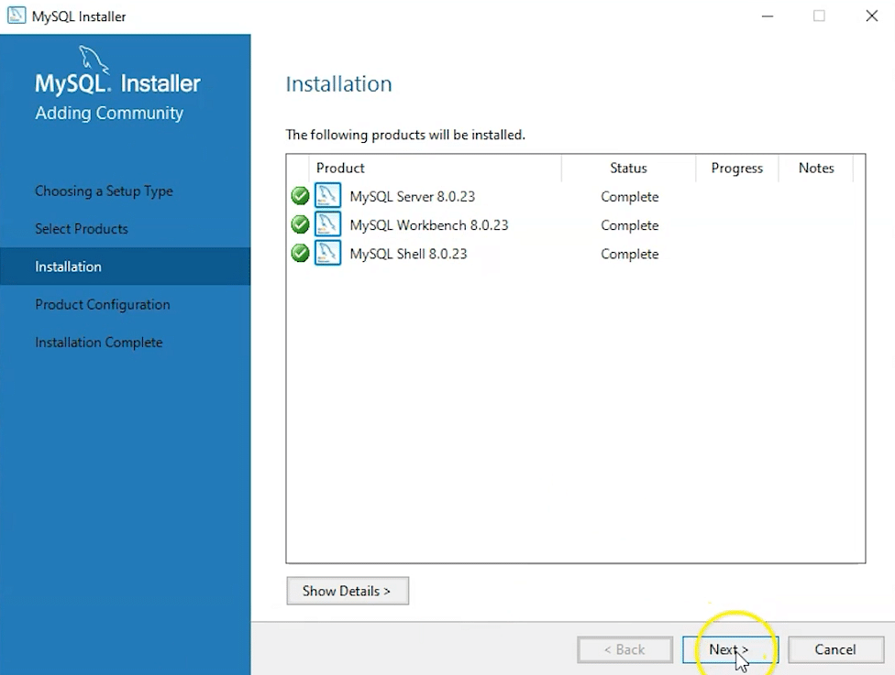
Step 10: Once the product is ready to configure, click on Next. Under Type and Networking, go with the default settings and select Next.
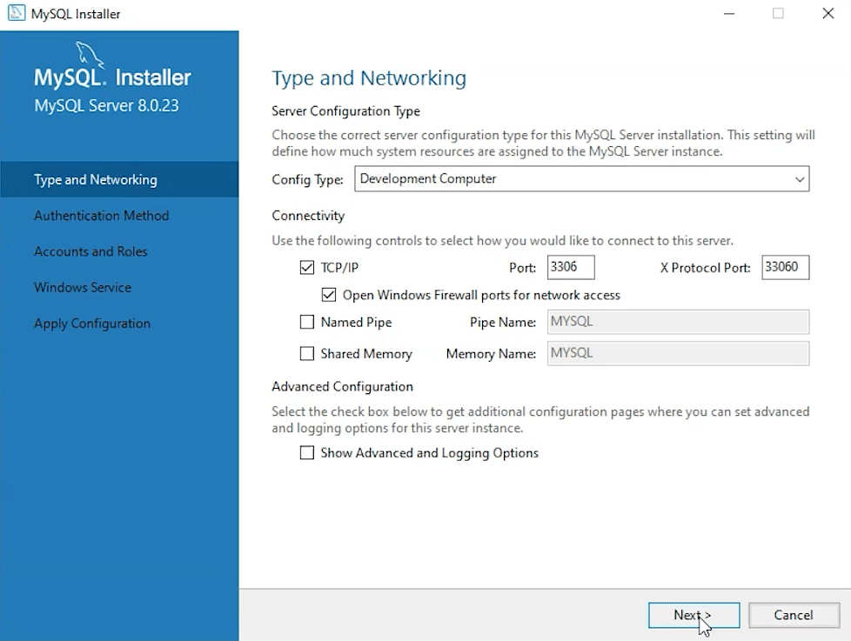
Step 11: For authentication, use the recommended strong password encryption.
Step 12: Set your MySQL Root password and click on next.
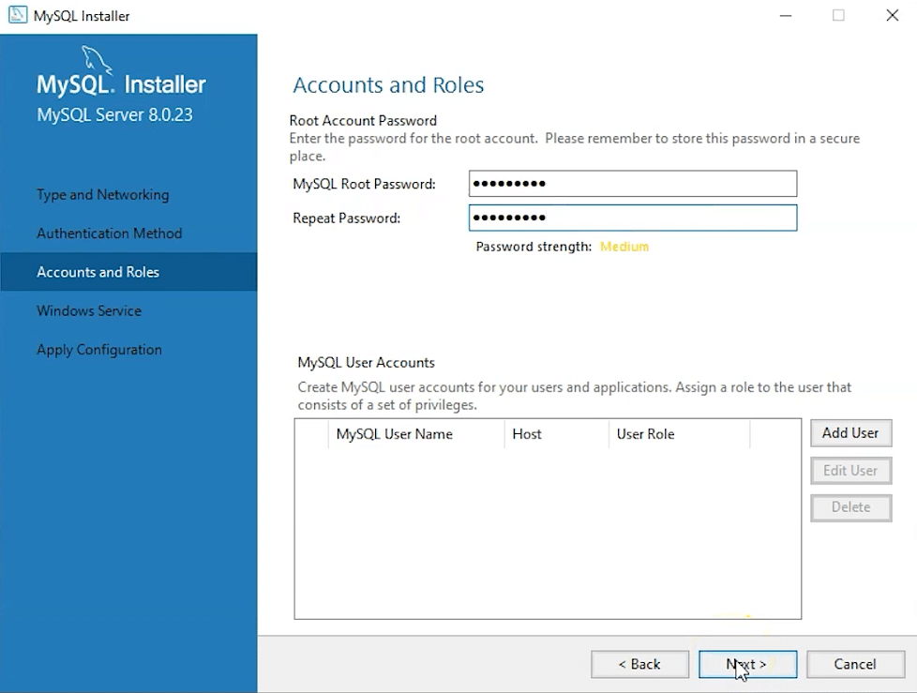
Step 13: Go for the default Windows service settings and under apply configuration, click on execute. Once the configuration is complete, click on finish.
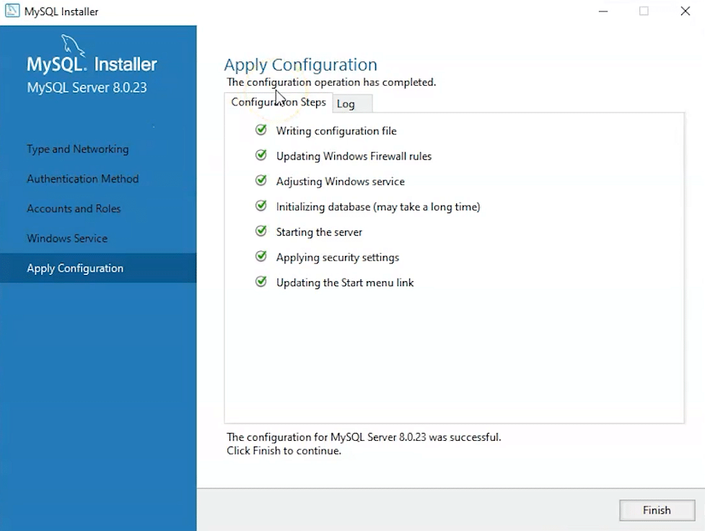
Step 14: Complete the installation. This will now launch the MySQL Workbench and the MySQL Shell.
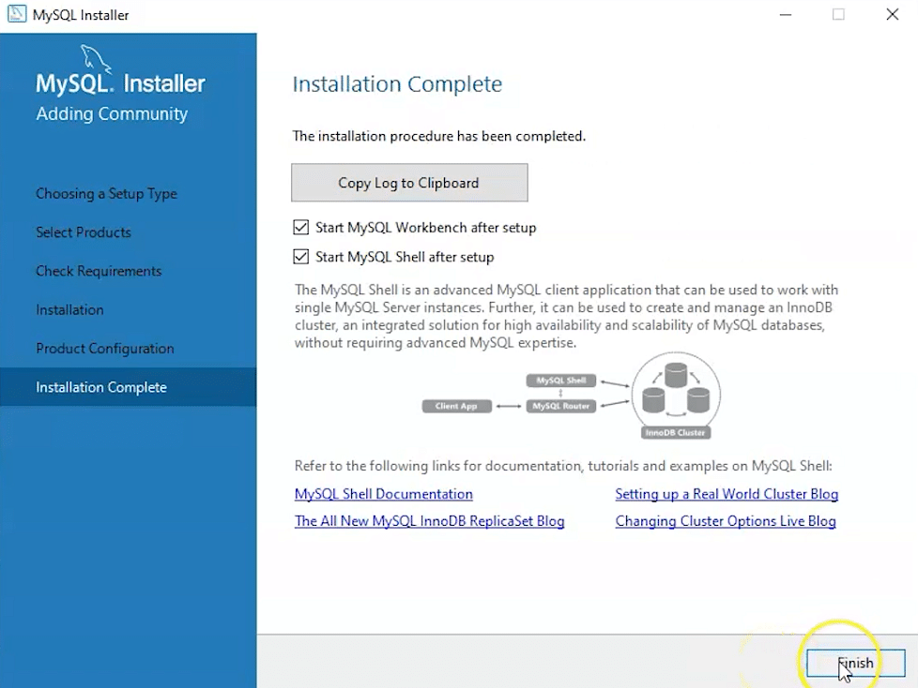
Once MySQL Workbench is installed, select the Local instance and enter the password.
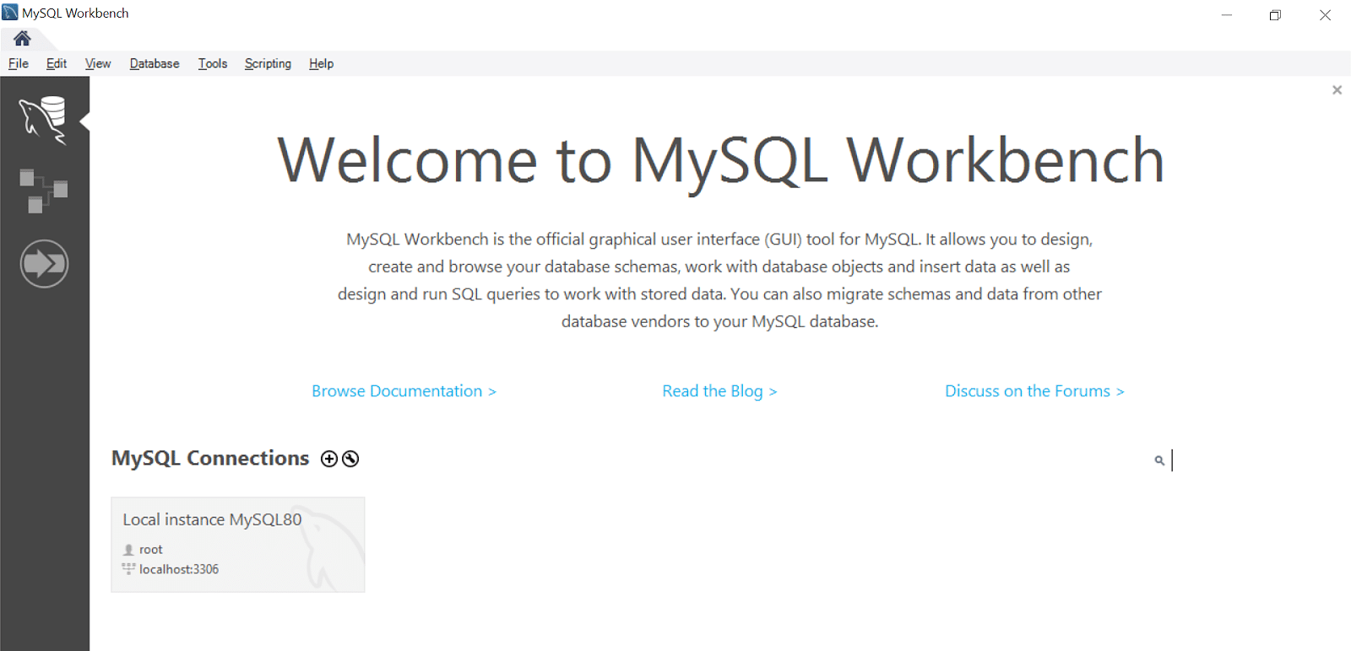
Now, you can use the MySQL query tab to write your SQL queries.

